Amends to Higher Math Student Book Exercises

UNIT 1

P58
Exercise 3A, Q1h

Should read y = 2 f(x) - 3

P69
Exercise 3D, Q3f

Should read y = 3 + 6^{(x-1)}

P73
Exercise 3E, Q3d

Should read y = log₂ (x + 3)

P78
Exercise 3F, Q10b

Should read y = 4cosxº + 3sinxº + 2

Exercise 3F, Q12b

Should read ‘value of x between 0 and 180’

P98
Exercise 5A, Q4i b

Should read 2p – 5q + r

P129
Exercise 6E, Q1

Vector for c should be included

UNIT 2

P184
Exercise 8D, Q7
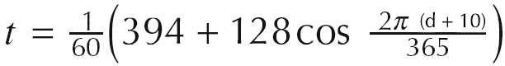
Should read

P193
Exercise 8G, Q3b

Should read cos4x + cos2x = 0, 0 ≤ x ≤ 2π

P219
Exercise 9C, Q6c

Should read f’(x)= x²

P229
Exercise 9F, Q1
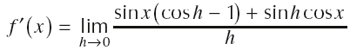
Should read

P242
Exercise 10A, Q11
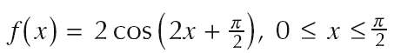
Should read

P257
Exercise 10C, Q7
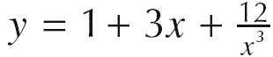
Should read

